****

**Lab Manual**

**For**

**EEE 1132 (Basic Electrical Circuits Lab)**

**Credit 1, Contact hour: 1.5 Hours per week**

**Department of Computer Science and Engineering**

**Varendra University**

**Rajshahi, Bangladesh**

****

**Varendra University**

**Deparment of Computer Science and Engineering**

**EEE 1132**

**Basic Electrical circuits Lab**

|  |  |
| --- | --- |
| Student ID |  |
| Student Name |  |
| Section |  |
| Semester |  |
| Name of the Program |  |
| Name of the Department |  |

**INDEX**

|  |  |  |  |
| --- | --- | --- | --- |
| **SL** |  | | **Pages** |
| **i** | INSTRUCTIONS FOR THE LABORATORY AND SAFETY RULES | |  |
| **ii** | COURSE SYLLABUS | |  |
| **iii** | NAME OF THE EXPERIMENTS | |  |
|  | **1.** | Verification of Kirchoff’s law (Current) |  |
|  | **2.** | Verification of Kirchoff’s law (Voltage) |  |
|  | **3.** | Verification of Superposition theorem. |  |
|  | **4.** | Verification of Thevenin’s theorem. |  |
|  | **5.** | Verification of Norton’s theorem. |  |
|  | **6.** | Verification of Maximum Power transfer theorem. |  |
|  | **7.** | Verification of resonance of a series RLC circuit. |  |
|  | **8.** | Lab Final Examination |  |

1. INSTRUCTIONS FOR THE LABORATORY AND SAFETY RULES

The following instruction and safety rules must be observed in all laboratory locations.

1. It is the duty of all concerned who use any electrical laboratory to take all reasonable steps to safeguard the HEALTH and SAFETY of themselves and all other users and visitors.

2. Be sure that all equipment is properly working before using for laboratory exercises. Any defective equipment must be reported immediately to the lab instructors or lab technical staff.

3. Students are allowed to use only the equipment provided in the experiment manual.

4. Power supply terminals connected to any circuit should only be energized in the presence of the instructor or lab staff.

5. Students should keep a safe distance from the electric circuits or any moving parts during the experiment.

6. Avoid any body contact between energized circuits and ground.

7. Switch off equipment and disconnect power supplies from the circuit before leaving the laboratory.

8. Maintain cleanliness and proper laboratory housekeeping of the equipment and other related accessories.

10. Double check your circuit connections before switching “ON” the power supply.

11. Make sure that the last connection to be made in your circuit is the power supply and first thing to be disconnected is also the power supply.

12. Equipment should not be removed or transferred to any location without taking permission from the laboratory staff.

15. Students are not allowed to use any equipment without proper orientation and actual hands-on equipment operation.

16. Smoking, eating, drinking, charging mobile phone, using own laptop and taking photos in the laboratory are strongly prohibited.

The above rules and regulations are necessary precautions in the electrical laboratory to

Safe guard the students, laboratory staff, the equipment and other laboratory users.

1. COURSE SYLLABUS

|  |  |  |  |  |  |  |  |
| --- | --- | --- | --- | --- | --- | --- | --- |
| 1 | Faculty | | | Faculty of Science and Engineering | | | |
| 2 | Department | | | Department of CSE | | | |
| 3 | Program | | | B. Sc in Computer Science and Engineering | | | |
| 4 | Name of the Course | | | Basic Electrical Circuits Lab | | | |
| 5 | Corse Code | | | EEE 1132 | | | |
| 6 | Bi-semester | | | July, 2023 | | | |
| 7 | Pre-requisites | | |  | | | |
| 8 | Status | | |  | | | |
| 9 | Credit Hours | | | 1.5 | | | |
| 10 | Section | | |  | | | |
| 11 | Class Hours | | |  | | | |
| 12 | Class Location | | | Digital Electronic Lab, Room: EAB 401 | | | |
| 13 | Name(s) of the Academic staff/ Instructor(s) | | | Arifa Ferdousi  Pallab Choudhury  Zannatul Mifta  Md. Aman Ullah | | | |
| 14 | Contact | | | [arifa@vu.edu.bd](mailto:arifa@vu.edu.bd)  [pallab@vu.edu.bd](mailto:pallab@vu.edu.bd)  [mifta@vu.edu.bd](mailto:mifta@vu.edu.bd)  [aman@vu.edu.bd](mailto:aman@vu.edu.bd) | | | |
| 15 | Office | | |  | | | |
| 16 | Counseling Hours | | |  | | | |
| 17 | Text Books | | | Electrical Circuits by B.L Thereja | | | |
| 18 | Reference | | | 1. [www.studocu.com](http://www.studocu.com) 2. [www.allaboutcircuits.com](http://www.allaboutcircuits.com) 3. [www.electronicshub.org](http://www.electronicshub.org) 4. [www.electronics-lab.com](http://www.electronics-lab.com) | | | |
| 19 | Equipments and Aids | | | 1. Lab sheet 2. Text Books | | | |
| 20 | Course Rationale | | | The objective of Electric Circuits laboratory is to impart hands on experience in verification of circuit laws and theorems, measurement of circuit parameters and study of circuit characteristics. It also gives practical exposure to the usage of Digital Oscilloscope, power sources, function generator etc. | | | |
| 21 | Course Description | | | This course presents the fundamentals of electrical circuit analysis. It begins with basic concepts such as voltage, current, sources, resistor, capacitor, inductor and Ohm's law; then it proceeds to develop general and powerful procedures such as KCL, KVL, nodal and mesh analyses, sinusoidal signal and their representation in phasor form, used in analyzing electric circuits. This course covers some fundamental theorems such as Superposition, Thevenin, Norton, Maximum power transfer theorem used in analyzing electric circuits. It also covers series and parallel RLC circuit and their application. | | | |
| 22 | Course Objectives | | | The course is designed to provide the background of the following topics:   1. Operate different types of instruments for circuit analysis. 2. Demonstrate the analysis of network theorems. 3. Examine the characteristics of RLC circuits. | | | |
| 23 | Course Outcomes | | | After the successful completion of this course, students will be able to  1. Operate different types of instruments for circuit analysis.  2. Demonstrate the analysis of network theorems.  3. Examine the characteristics of RLC circuits. | | | |
| 24 | Teaching Methods | | | Lecture, Presentation, Problem solving | | | |
| 25 | Topic Outline | | | | | | |
|  | Class | Topics | | | COs | Reading reference | Activities |
|  | 1-2 | Get the fundamental conception of Electrical circuits, basic electrical laws, alternating currents, voltage and its different properties and theorems, voltmeter, ammeter, ohmmeter, KCL and KVL | | |  |  | Problem solving, question answer, Verify KCL, KVL |
|  | 3 | Implementation of Superposition theorem with necessary circuit diagram and result table. | | |  |  | Problem solving, question answer, Verify superposition theorem |
|  | 4 | Implementation of Thevenin’s theorem with necessary circuit diagram and result table. | | |  |  | Problem solving, question answer, Verify Thevenin’s theorem |
|  | 5 | Implementation of Norton’s theorem with necessary circuit diagram and result table. | | |  |  | Problem solving, question answer, Verify Norton’s theorem |
|  | 6 | Implementation of Maximum Power Transfer theorem with necessary circuit diagram and result table. | | |  |  | Problem solving, question answer, Verify maximum Power transfer theorem |
|  | 7 | Series RLC circuit | | |  |  | Problem solving, question answer, calculate resonance frequency theorem |
|  | 8 | Quiz | | |  |  | Problem solving, Multiple choice |
|  | 9-10 | Lab Final | | |  |  | Lab test, Viva, |
|  |  | | | | | | |
| 26 | Assessment Methods | | |  |  | | --- | --- | | Assessment Types | Marks | | Attendance | 10% | | Experiment | 10% | | Laboratory Viva-voce | 10% | | Laboratory Report | 20% | | Final Lab Viva | 10% | | Lab Final | 15% | | Lab Quiz | 25% | | Total | 100% | | | | | |
| 27 | Grading Policy | | H:\Lab Manual CSE-121\Capture.PNG | | | | |
| 28 | Additional Course Policies | | * 1. . Lab Reports   Reports on previous Experiment must be submitted before the beginning of new experiment. A bonus mark may be obtained if a sutdents submits a neat, clean and complete lab report.  2.2 Examination  There will be a lab exam at the end of the semester that will be a closed book exam.  3.3. Unfair means policy  In case of copying/ plagiarism in any of the assessments, the students involved will receive zero marks. Zero Tolarance will be shown in this regard. In case of severel offences, actions will be taken as per university rule.  4.4. Counseling  Students are expected to follow the counselling hours posted. In case of emergency/ unavoidable situation, students can e-mail the respective teachers for an appoinment.  5.5. Policy for Absence in Class/ Exam  If a student is absent in the class for anything other than medical reasons, he/she will not receive attedance. If a student misses a class for genuine medical reasons, he/she must apply with the supporting documents . He/she will then have to follow the instructions given by the instructor for make-up.  In case of absence in the mid/ final exam for medical grounds, the student must also get his/ her application forwarded by the head of the department before a make-up exam can be taken.  It is recommended that the student inform the instructor beforehand through mail if they feel that they will miss a class / evaluation due to medical reasons. | | | | |
| 29 | Additional info | |  | | | | |

**Experiment No. 1:**

**Name of the Exp.:** Verification of Kirchhoff’s Current Law (KCL).

**Objective**: To verify Kirchhoff’s current law (KCL) theoretically and experimentally for the given circuits.

**Theory:**

KCL states that the algebraic sum of the currents meeting at a node is equal to zero.

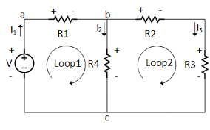

Figure 1: Circuit diagram for Kirchhoff’s current law.

**Apparatus**:

1. DC power supply
2. Resistors
3. Digital Multi-meter
4. Bread Board
5. Connecting wires

**Procedure:**

**KCL**

1. Check the values of the resistor using a multi-meter ( ohm section of multi-meter). Record the values in Table -1.
2. Give the connection as per the circuit diagram shown in Fig.2.
3. Set a particular value in the DC power supply.
4. Measure circuit current and branch currents and record their values in Tabel-3.
5. Sum up the ammeter readings (I1 , I2 …) that should be equal to the total currents.
6. Repeat the same for different voltages.
7. Verify KCL for each set of data.

**Observations:**

**Tabel-1:** Resistor values

|  |  |  |  |  |  |  |  |  |  |
| --- | --- | --- | --- | --- | --- | --- | --- | --- | --- |
| Resistors | R1 | R2 | R3 | R4 | R5 | R6 | R7 | R8 | R9 |
| Ohm meter reading |  |  |  |  |  |  |  |  |  |

**Table -2:** Experimental and theoretical data for Kirchhoff’s current law (KCL).

TV = Theoretical Value MV = Measured Value

|  |  |  |  |  |  |  |  |  |  |  |  |
| --- | --- | --- | --- | --- | --- | --- | --- | --- | --- | --- | --- |
| No. of Observation | V (V) | I (A) | | I1 (A) | | I2 (A) | | I3 (A) | | I1 =I2+ I3  (A) | |
|  |  | TV | MV | TV | MV | TV | MV | TV | MV | TV | MV |
|  |  |  |  |  |  |  |  |  |  |  |  |

**Model Calculation:**

**Results:**

1. Show the results in Tabular form.
2. Comments on the result obtained and discrepancies (in any).

**Precautions:**

1. Check for proper connections before switching ON the supply.
2. Take care of the reading of the apparatus.
3. The terminal of the resistance should be properly connected.

**Experiment No. 2:**

**Name of the Exp.:** Verification of Kirchhoff’s Voltage law (KVL).

**Objective**: To verify Kirchhoff’s voltage law (KVL) theoretically and experimentally for the given circuits.

**Theory:**

KVL states that in any closed path / mesh, the algebraic sum of all the voltages is zero.

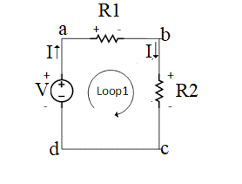

Fig-1: Circuit diagram for Kirchhoff’s voltage and Kirchhoff’s current law.

**Apparatus**:

1. DC power supply
2. Resistors
3. Digital Multi-meter
4. Bread Board
5. Connecting wires

**Procedure:**

**KVL**

1. Check the values of the resistor using a multi-meter (ohm section of multi-meter). Record the values in Table -1.
2. Give the connection as per the circuit diagram shown in Fig.1.
3. Set a particular value in the DC power supply.
4. Measure the voltage drops in the circuit and record their values in Table -2.
5. Sum up the voltmeter readings i.e. voltage drops that should be equal to the applied voltage.
6. Repeat the same for different voltages.
7. Verify KVL for each set of data.

**Observations:**

**Tabel-1:** Resistor values

|  |  |  |  |  |  |  |  |  |  |
| --- | --- | --- | --- | --- | --- | --- | --- | --- | --- |
| Resistors | R1 | R2 | R3 | R4 | R5 | R6 | R7 | R8 | R9 |
| Ohm meter reading |  |  |  |  |  |  |  |  |  |

**Table -2:** Experimental and theoretical data for Kirchhoff’s voltage law (KVL)

TV = Theoretical Value MV = Measured Value

|  |  |  |  |  |  |  |  |
| --- | --- | --- | --- | --- | --- | --- | --- |
| No. of Observation | V (V) | V1 (V) | | V2 (V) | | V=V1+ V2 | |
|  |  | TV | MV | TV | MV | TV | MV |
|  |  |  |  |  |  |  |  |

**Model Calculation:**

**Results:**

1. Show the results in Tabular form.
2. Comments on the result obtained and discrepancies (in any).

**Precautions:**

1. Check for proper connections before switching ON the supply.
2. Take care of the reading of the apparatus.
3. The terminal of the resistance should be properly connected.

**Experiment No. 3:**

**Name of the Exp.:** Verification of Superposition theorem.

**Objective**: To verify Superposition theorem theoretically and experimentally which is an analytical technique of determining currents in a circuit with more than one emf source.

**Theory:**

In a circuit (network) made up of linear elements (e.g. resistors) and containing two or more sources of emf, the current in any particular branch when all the emf sources are acting simultaneously may be found by considering the sources of emf to act one at a time, then finding the current in the specified branch due to each source and then superimposing, or adding algebraically, these component currents.

**Note regarding Superposition theorem**:

While the current due to a particular source of emf is being found the other emf sources are rendered inactive and if any branch element is in series with those sources that remains intact.

**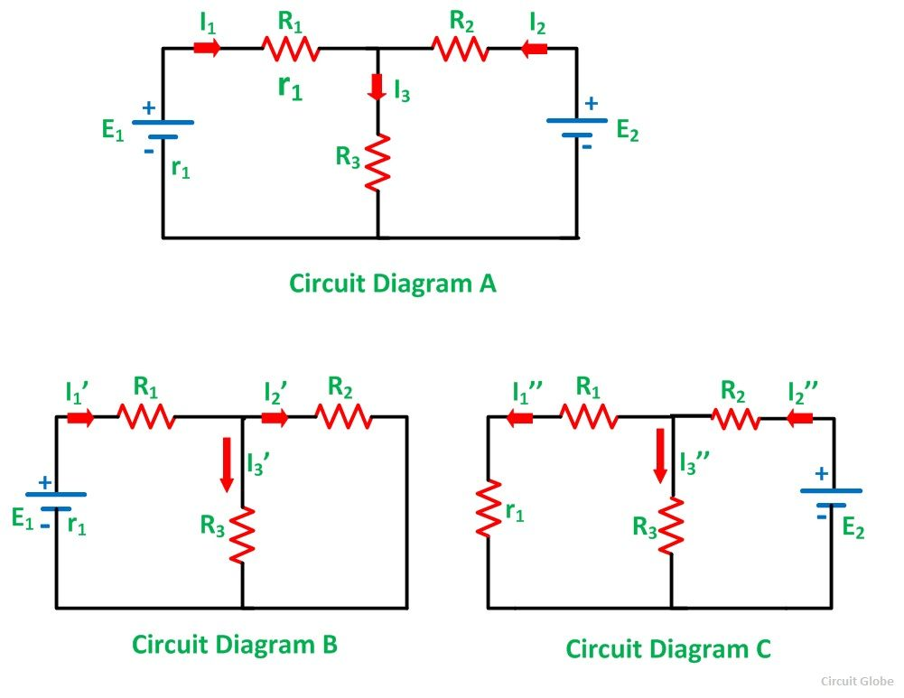**

Fig- Circuit diagram for superposition theorem.

**Apparatus**:

1. DC power supplies
2. Resistors
3. Digital Multi-meter
4. Bread Board
5. Connecting wires

**Procedure:**

1. Check the values of the resistor using a multi-meter (ohm section of multi-meter). Record the values in Table -1.
2. Give the connection as per the circuit diagram shown in Fig1.B.
3. Set a particular value in the DC power supply. ( E1 = 5V)
4. Measure circuit current and branch currents and record their values in Tabel-2.
5. Give the connection as per the circuit diagram shown in Fig 1.C.
6. Set a particular value in the DC power supply. ( E2 = 7V)
7. Measure circuit current and branch currents and record their values in Tabel-2
8. Give the connection as per the circuit diagram shown in Fig.1.A.
9. Measure circuit current and branch currents and record their values in Tabel-2
10. Repeat the procedure for different values of E1 and E2.

**Observations:**

**Tabel-1:** Resistor values

|  |  |  |  |  |  |  |  |  |  |
| --- | --- | --- | --- | --- | --- | --- | --- | --- | --- |
| Resistors | R1 | R2 | R3 | R4 | R5 | R6 | R7 | R8 | R9 |
| Ohm meter reading |  |  |  |  |  |  |  |  |  |

**Table -2:** Experimental and theoretical data for Fig-2 (E1 active and E2 inactive)

|  |  |  |  |  |  |  |  |  |  |
| --- | --- | --- | --- | --- | --- | --- | --- | --- | --- |
| No. of Observation | E1(V) | I (A) | | I ‘1 (A) | | I ‘2 (A) | | I ‘3 (Volts) | |
|  |  | TV | TV | TV | TV | TV | TV | TV | TV |
|  |  |  |  |  |  |  |  |  |  |

**Table -3:** Experimental and theoretical data for Fig-2 (E2 active and E1 inactive)

|  |  |  |  |  |  |  |  |  |  |
| --- | --- | --- | --- | --- | --- | --- | --- | --- | --- |
| No. of Observation | E2(V) | I (A) | | I ‘’1 (A) | | I ‘’2 (A) | | I ‘’3 (Volts) | |
|  |  | TV | TV | TV | TV | TV | TV | TV | TV |
|  |  |  |  |  |  |  |  |  |  |

**Table -4:** Experimental and theoretical data for Fig-2 (E1 active and E2 active)

|  |  |  |  |  |  |  |  |  |
| --- | --- | --- | --- | --- | --- | --- | --- | --- |
| No. of Observation | E1(V) | E2(V) | I1 (A) | | I 2 (A) | | I 3 (Volts) | |
|  |  |  | TV | MV | TV | MV | TV | MV |
|  |  |  |  |  |  |  |  |  |

**Model Calculations:**

**Results:**

1. Show the results in Tabular form.
2. Comments on the result obtained and discrepancies (in any).

**Precautions:**

1. Check for proper connections before switching ON the supply.
2. Take care of the reading of the apparatus.
3. The terminal of the resistance should be properly connected.

**Experiment No. 4**:

**Name of the Exp.:** Verification of Thevenin’s theorem.

**Objective**: To verify Thevenin's theorem with reference to a given circuit theoretically as well as experimentally.

**Theory:**

Thevenin’s theorem states that any two terminal linear bilateral network containing sources and passive elements can be replaced by an equivalent circuit consisting of a voltage source Vth in series with a resistor Rth where.

Vth= The open circuit voltage (VOC) at the two terminals A & B.

Rth = The resistance looking into the terminals A and B of the network with all sources removed.

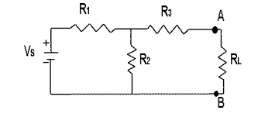

Fig-1: Circuit Diagram for Thevenin’s theorem.

**Apparatus**:

1. DC power supplies
2. Resistors
3. Digital Multi-meter
4. Bread Board
5. Connecting wires

**Procedure:**

1. Check the values of the resistor using multi-meter (ohm section of multi-meter). Record the values in Table -1.
2. Give the connection as per the circuit diagram shown in Fig.1

**FINDING VTh & RTH :**

1. Remove the load resistance RL and find the open circuit voltage between terminals A & B. This voltage is Thevenin voltage i.e. VTH=VOC.
2. Replace the voltage sources with short circuits. With RL removed from the circuit, measure Rth using a Multimeter. Or
3. Place a short circuit between terminals A & B and find the short circuit current ISC. Divide the open circuit voltage by the short circuit current to find the Thevenin resistance RTH i.e.

Rth = Voc/Isc

1. Record the results in Table 2

**Observations:**

Tabel-1: Resistor values

|  |  |  |  |  |  |  |  |  |  |
| --- | --- | --- | --- | --- | --- | --- | --- | --- | --- |
| Resistors | R1 | R2 | R3 | R4 | R5 | R6 | R7 | R8 | R9 |
| Ohm meter reading |  |  |  |  |  |  |  |  |  |

Table -2: Experimental and theoretical data for Fig-2 and Fig-3

|  |  |  |  |  |  |  |  |  |  |
| --- | --- | --- | --- | --- | --- | --- | --- | --- | --- |
| No. of Observation | Vs(V) | Vth (Volt) | | Rth(ohm) | | IL (A) From Circuit -1 | | IL(A) form thevenins equivalent circuit. | |
|  |  | TV | MV | TV | MV | TV | MV | TV | MV |
|  |  |  |  |  |  |  |  |  |  |

**Model Calculation:**

**Results:**

1. Show the results in Tabular form.
2. Comments on the result obtained and discrepancies (in any).

**Precautions:**

1. Check for proper connections before switching ON the supply.
2. Take care of the reading of the apparatus.
3. The terminal of the resistance should be properly connected.

**Experiment No. 5:**

**Name of the Exp.:** Verification of Norton’s theorem.

**Objective:** To verify Norton's theorem with reference to a given circuit theoretically as well as experimentally.

**Theory:**

Norton’s theorem states that any two-terminal linear bilateral networks containing sources and passive elements can be replaced by an equivalent circuit consisting of a current source IN in parallel with a resistor RN where

IN= The short circuit current (ISC) at the two terminals A & B.

RN = The resistance looking into the terminals A and B of the network with all sources removed.



Fig-1: Circuit Diagram for Norton’s theorem.

**Apparatus**:

1. DC power supplies
2. Resistors
3. Digital Multi-meter
4. Bread Board
5. Connecting wires

**Procedure:**

1. Check the values of the resistor using multi-meter (ohm section of multi-meter). Record the values in Table -1.
2. Give the connection as per the circuit diagram shown in Fig.1

**FINDING IN & RN :**

1. Short the load resistance RL and find the short circuit current between terminals A & B. This current is Norton current i.e. IN=ISC.
2. Replace the voltage sources with short circuits and current sources with open circuit. With RL removed from the circuit, measure RN using a multimeter (Ammeter).
3. Record the results in Table 2

**Observations:**

Tabel-1: Resistor values

|  |  |  |  |  |  |  |  |  |  |
| --- | --- | --- | --- | --- | --- | --- | --- | --- | --- |
| Resistors | R1 | R2 | R3 | R4 | R5 | R6 | R7 | R8 | R9 |
| Ohm meter reading |  |  |  |  |  |  |  |  |  |

Table -2: Experimental and theoretical data for Fig-2 and Fig-3

|  |  |  |  |  |  |  |  |  |  |
| --- | --- | --- | --- | --- | --- | --- | --- | --- | --- |
| No. of Observation | VS(V) | IN (A) | | RN(ohm) | | IL (A) From circuit-1 | | IL(A) form Norton’s equivalent circuit. | |
|  |  | TV | MV | TV | MV | TV | MV | TV | MV |
|  |  |  |  |  |  |  |  |  |  |

**Model Calculations:**

**Results:**

1. Show the results in Tabular form.
2. Comments on the result obtained and discrepancies (in any).

**Precautions:**

1. Check for proper connections before switching ON the supply.
2. Take care of the reading of the apparatus.
3. The terminal of the resistance should be properly connected.

**Experiment No. 6:**

**Name of the Exp.:** Verification of Maximum Power transfer theorem.

**Objective:** The objective of this experiment is to verify maximum power transfer theorem theoretically and experimentally for the given circuit.

**Theory:**

In a linear, bilateral circuit the maximum power will be transferred to the load when load resistance is equal to source resistance. or

In a resistive circuit, a resistive load receives maximum power when the load resistance is equal to Thevenin’s equivalent resistance of the circuit (i.e. RL = RTH). The maximum power can be calculated using the expression:

P = V2oc / 4RTH

where VTH is the open circuit voltage.

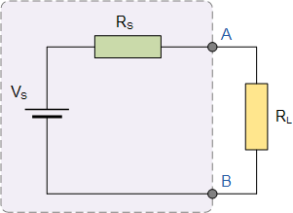

Fig-1: Circuit Diagram for Maximum Power transfer theorem

**Apparatus**:

1. DC power supplies
2. Resistors
3. Digital Multi-meter
4. Bread Board
5. Connecting wires

**Procedure:**

1. Check the values of the resistor using a multi-meter (ohm section of multi-meter). Record the values in Table -1.
2. Give the connection as per the circuit diagram shown in Fig.1
3. Replace the load resistor between A and B with a variable resistor (i.e. RL in this case is the variable resistor).
4. Vary RL and measure VL and IL in each case. Record the results in Table 2.
5. Calculate PL from the measured values of VL and IL and record the result in Table 2.

**Observations:**

**Tabel-1:** Resistor values

|  |  |  |  |  |  |  |  |  |  |
| --- | --- | --- | --- | --- | --- | --- | --- | --- | --- |
| Resistors | R1 | R2 | R3 | R4 | R5 | R6 | R7 | R8 | R9 |
| Ohm meter reading |  |  |  |  |  |  |  |  |  |

**Table -2:** Experimental and theoretical data Maximum power transfer theorem.

|  |  |  |  |  |  |  |  |  |
| --- | --- | --- | --- | --- | --- | --- | --- | --- |
| No. of Observation | VS(V) | RL(ohm) | IL (A) | | VL(volts) | | PL = VLIL(watts) | |
|  |  |  | TV | MV | TV | MV | TV | MV |
|  |  |  |  |  |  |  |  |  |
|  |  |  |  |  |  |  |  |  |
|  |  |  |  |  |  |  |  |  |
|  |  |  |  |  |  |  |  |  |
|  |  |  |  |  |  |  |  |  |
|  |  |  |  |  |  |  |  |  |
|  |  |  |  |  |  |  |  |  |
|  |  |  |  |  |  |  |  |  |

**Model Calculations:**

**Results:**

1. Show the results in Tabular form.
2. Comments on the result obtained and discrepancies (in any).

**Precautions:**

1. Check for proper connections before switching ON the supply.
2. Take care of the reading of the apparatus.
3. The terminal of the resistance should be properly connected.

**Experiment No. 7:**

**Name of the experiment :** Verification of resonance of a series RLC circuit.

**Objective :** To design the resonant frequency, quality factor and band width of a series RLC circuit.

**Theory:**

An AC circuit is said to be in Resonance when the applied voltage and current are in phase. Resonance circuits are formed by the combination of reactive elements connected in either series or parallel.

Resonance frequency in series circuit is given by fr = 1/ (2π √LC) Hz

The impedance of the RLC circuit is

Z = R + j ( ωL – 1/ωC) = R + jX

The circuit is in resonance when X = 0 ie., when ωL = 1/ωC

In a series RLC circuit the current lags behind or leads the applied voltage depending upon the value of XL and Xc. When XL is greater than Xc the circuit is inductive and when Xc is greater than XL, the circuit is capacitive.

Quality factor ( Q-factor) or (Selectivity) :

Quality factor can be defined as ,

= 2 π (maximum energy stored )/ ( energy dissipated per cycle).

= (f2 – f1) / fr

**Band width**: The band width of a resonance circuit is defined as the band of frequencies on either sides of the resonance frequency. This frequency range can be obtained by dropping a vertical in the graph at its half power value, i.e.,

1/ √2 times of maximum value.

Band width = f2 – f1

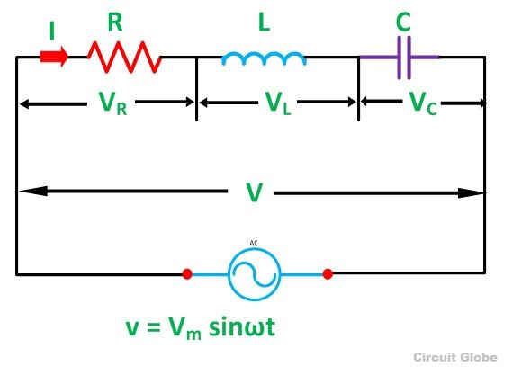

Fig-1: Circuit Diagram series RLC circuit

For oscilloscope:

V_{p} = divisions \times Y gain

To calculate the r.m.s. voltage from the peak voltage the factor of \frac{1}{\sqrt2} is used.

V_{rms}=\frac{V_{peak}}{\sqrt2}

There is a similar relationship between r.m.s. and peak current.

I_{rms}=\frac{I_{peak}}{\sqrt2}

THEORETICAL CALCULATIONS:

**Series Resonance**

1. Resonant Frequency (fr) = 1/(2π√LC)
2. Lower cut off frequency (f1) = fr-R/4πL
3. Upper cut off frequency (f2) = fr+R/4πL Quality
4. factor Qr = ωrL/R = 1/ωrRC
5. Band Width f2-f1 = R/2πL

Apparatus:

1. Signal generator
2. Resistors
3. Inductors
4. capacitors
5. Digital Oscilloscope
6. Connecting wires
7. Digital Multimeters
8. Bread Board

**PROCEDURE:**

1. Connect the circuit as shown in fig.1 for series resonant circuit

2. Set the voltage of the signal from function generator (RMS value).

3. Vary the frequency of the signal in steps and note down the magnitude of response on Oscilloscope respectively.( response waveform is observed across element R) and record it table -2.

4. Calculate the Impedance Z.

5. Plot the graphs for current Vs frequency and Z Vs frequency

6. Also plot the graph of Voltage Vs Frequency.

7. Identify the values of f0 , f1 and f2 from the graph, Calculate the Q-factor and Band width.

**Observations:**

**Tabel-1:** Resistor values

|  |  |  |  |
| --- | --- | --- | --- |
| Resistors, R (ohms) | Inductor, L(mH( | Capacitor, C(μF) | Applied Voltage, VS (V) |
|  |  |  |  |

**Table -2:** Experimental and theoretical data Maximum power transfer theorem.

|  |  |  |  |  |
| --- | --- | --- | --- | --- |
| No. of Observation | Frequency,f (KHz) | Voltage across Resisor, VR(Volts) | Current through resistor, IR(A) | Impedance,  Z = V / IR (ohm) |
|  |  |  |  |  |
|  |  |  |  |  |
|  |  |  |  |  |
|  |  |  |  |  |
|  |  |  |  |  |
|  |  |  |  |  |

**Results:**

1. Show the results in Tabular form.
2. Comments on the result obtained and discrepancies (in any).

**Precautions:**

1. Check for proper connections before switching ON the supply.
2. Take care of the reading of the apparatus.
3. The terminal of the components should be properly connected.